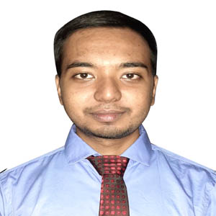

**BIPLOB KUMAR PAINE**

**Organized, Technical, Analytical**

Being an engineering graduate, I am willing to work in such an environment which provides me challenges and opportunities to expose my knowledge and potentials through my technical skills and hard work. I have a proactive attitude and like to find positive ways to stimulate and engage with people. I believe that if I am given the opportunity to serve, I can provide dedication and devotion to the assigned job.

**2013**

* **BSc in Computer Science and Engineering**

American International University-Bangladesh (AIUB), Dhaka.

G.P.A- 3.59 out of 4.00

N.S Govt. College, Natore.

G.P.A- 4.33 out of 5.00

* **Higher Secondary Certificate**

**2015**

United International University (UIU), Dhaka.

Major: Cyber Security

* **MSc in Computer Science and Engineering**

**EXPERIENCE**

annanto2248@gmail.com

**🖂**

**🕽**

+8801772976852

**🏠**

Nadda, Kalachadpur, Dhaka

**EDUCATION**

**2022-Present**

**CONTACT**

**2016-2021**

* Completed 06 months internship as “Trainee Cloud Network Engineer” at MF ASIA LTD. In my internship period, I have contributed some specific fields. These are

**-** Worked on Nagios Development

Project.

- Network Monitoring (Using

Nagios)

- Smoke Testing (Tested the whole

site after upgradation.

- Client Support.

* **Secondary School Certificate**

Natore Govt. Boys’ High School, Natore.

G.P.A- 5.00 out of 5.00

**G.P.A- 5.00 out of 5.00**

**SKILL and Achievement**

* Completed CCNAv7: Introduction to Networks; Switching, Routing, and Wireless Essentials; Enterprise Networking, Security, and Automation and got certificate from CISCO Networking Academy.
* Completed NDG Linux Essentials course and got certificate from CISCO Networking Academy.
* Completed Red Hat System Administration I 7, Red Hat System Administration II 7, Red Hat System Administration III 7 and got certificate from Red Hat Academy.

**LANLUAGE**

* Bangla (Native).
* English

**REFERENCE**

**HOBBY**

* Bike Riding
* Gardening
* Watching Science Fiction Movie

**DECLARATION**

Undersigned certified that to the best of my knowledge and belief this resume correctly describes my qualifications and me. Any wilful misstatement describes here in may lead to my disqualification or dismissal, if I employed.

* Manik Roy

Director

MF ASIA LTD

E-mail: [manik@metafour.com](mailto:manik@metafour.com)

* DR. MOHAMMAD NURUL HUDA

Director & Professor

Dept. of CSE, UIU

E-mail: [mnh@cse.uiu.ac.bd](mailto:mnh@cse.uiu.ac.bd)

**REFERENCE**



(Signature)

--------------------